**Tutorial 1 Assignment:**

**Task:** Counting number of lines and printing them in an order

**Input:**

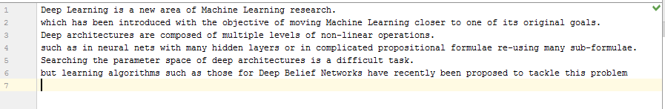

**Output:**

